
PALMYRA TOWNSHIP, PIKE COUNTY
CLEAN-UP DAY
Saturday May 31, 2025
➔➔➔ 8:00 AM - 12:00 Noon ⬅⬅⬅
at the Township Building - off Gumbletown Road

AUTO, $30
SUV/SM PICK-UP/……………………………………………………………………………………$40
Small Trailer……………………………………………………………………………………………..$60
Large pick-up or trailer $75
1-ton dump or flatbed truck /box truck…………………………………………………….$100
Chair/Sofa………………………………………………………………………………………….$20/$25
Car Battery………………………………………………………………………………………No Charge
Mattress or Box Spring…………………………………………………………………………….$25
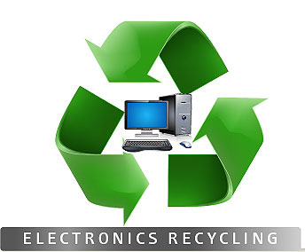
ALSO AVAILABLE:
ELECTRONICS RECYCLING
Items Accepted: computers, monitors, printers, keyboards, mouse, cell phones, scanners, cables, fax machines, radios, modems, telephones, televisions, DVD/VCRs, copiers, typewriters, stereo equipment, etc. There is no charge for Palmyra Township residents utilizing the E-Cycling- PROOF OF RESIDENCY WILL BE REQUIRED

NO TRUCKS OVER ONE TON
WILL NOT ACCEPT: tires, paints, thinner, oil, pesticides, herbicides, dirt, cement, any hazardous materials, boats, LP gas tanks, styrofoam, deck or dock lumber. Nothing will be accepted prior to May 31, 2025.

